Describe the map. Use the right prepositions to fill in the sentences.
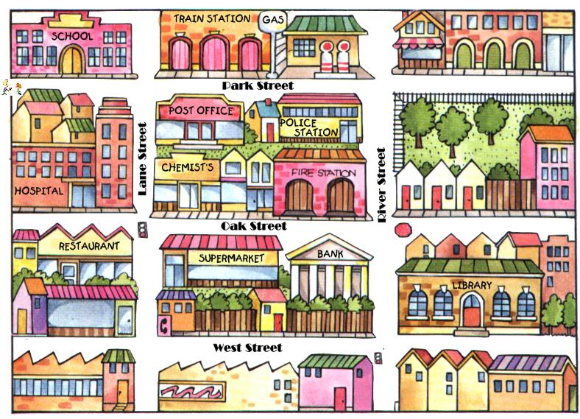

a) The supermarket is ……………………… the restaurant.

b) The train station is ………………………. the school.

c) The hospital is …………………………….. the restaurant.

d) The supermarket is ……………………….. the bank.

e) The school is …………………. the hospital.

f) The post office is …………….. the train station.

g) The bank is ……………….West Street.

h) The police station is ………….the gas station.

i)The chemist’s is ……………the hospital and the fire station ……… Oak Street.

You are at the School, you must go to the library. Explain the directions to follow.

………………………………………………………………………………………………………………………………………………………………………………………………………………………………………………………………………………………………………………………………………………………………………………………………………………………………………………………

