5e 2015 UNIT 1 – LESSON 2 : MY DREAM TOWN

VOCABULARY :
On the left On the right In the middle
Lights a flag a telephone box the sea a food shop
A pier (to) take photos

RECAP : BRIGHTON
Palace Pier is famous around the world. It is illuminated by thousands of lights. It is 524 meters long. There are lots of attractions on the Pier, there are restaurants and bars and there is also a fun fair at the end of the Pier. There are arcades with video games, but there aren’t any clothes shop.

GRAMMAR : PRESENTING A PLACE

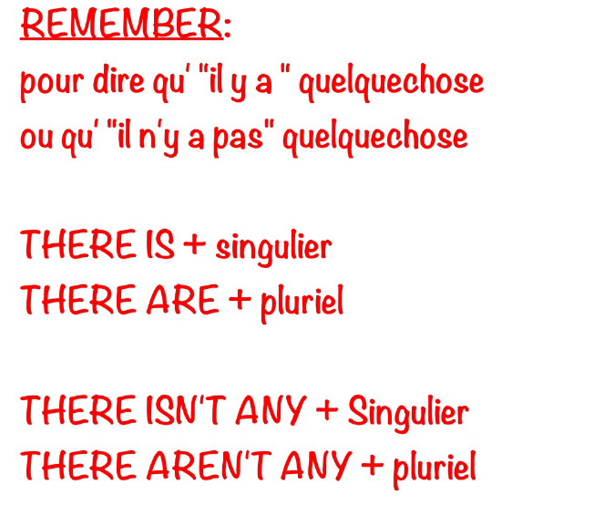
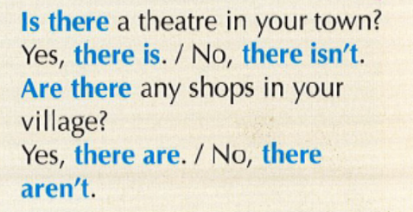

VOCABULARY : TALKING ABOUT PLACES
