5e 2015 UNIT 1 – LESSON 1 : ASKING ABOUT DIRECTIONS

VOCABULARY : DIRECTIONS
Turn right Turn left Go straight on

DESCRIPTION : TB p 14
On the picture, I can see some teenagers and a man. I think they are a group of students because they have uniforms. Maybe they are with their teacher, on a class outing. They are looking at a map to find directions. Maybe they want to visit the Royal Pavilion.

VOCABULARY:
A uniform A student A teacher A class outing (to) Visit
A map (to) Look at (to) look for

RECAP :
A group of students are visiting Brighton with their teacher, they can listen to an audio guide. They must come in front of the Pier at 12.30.
They are in Prince Albert Street. If they go straight on , they will see the Townhall on their right , and if they turn right after that, they will see the aquarium on their left. The Pier will be in front of them.

VOCABULARY :
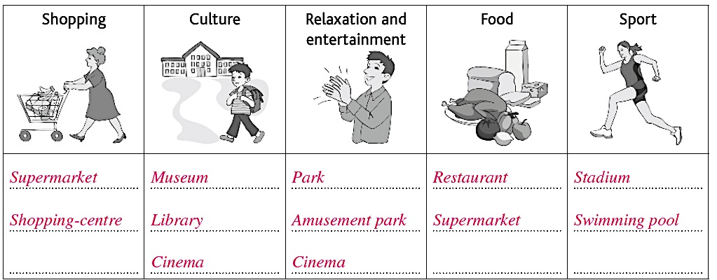

PREPOSITIONS
Opposite between at the corner of next to on the right on the left

GRAMMAR :
Pour indiquer le chemin à suivre on utilise l'impératif:
Go - DON'T go Turn - DON'T turn walk - DON'T walk

USEFUL EXPRESSIONS:
GO DOWN....street TURN LEFT/RIGHT INTO... street
GO STRAIGHT ON WALK PAST...
CROSS STOP

